|  |  |
| --- | --- |
| **Name :-** | Aryan Dilipbhai Langhanoja |
| **Enroll No: -** | 92200133030 |

**Washing machine control using basic AND & NOT gates**

* **Aim** :-

To construct logic circuit of washing machine control using a generalized simulator and verify its output.

* **Pre-test :-**

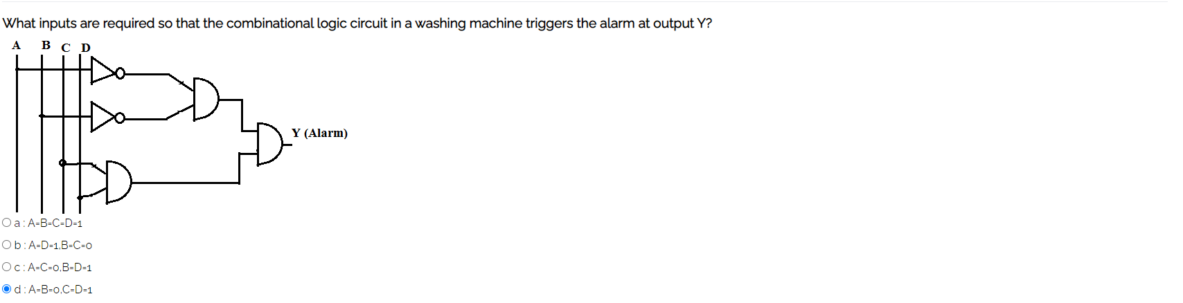

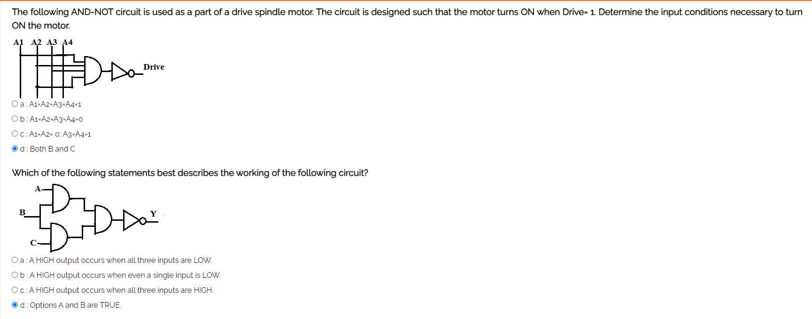

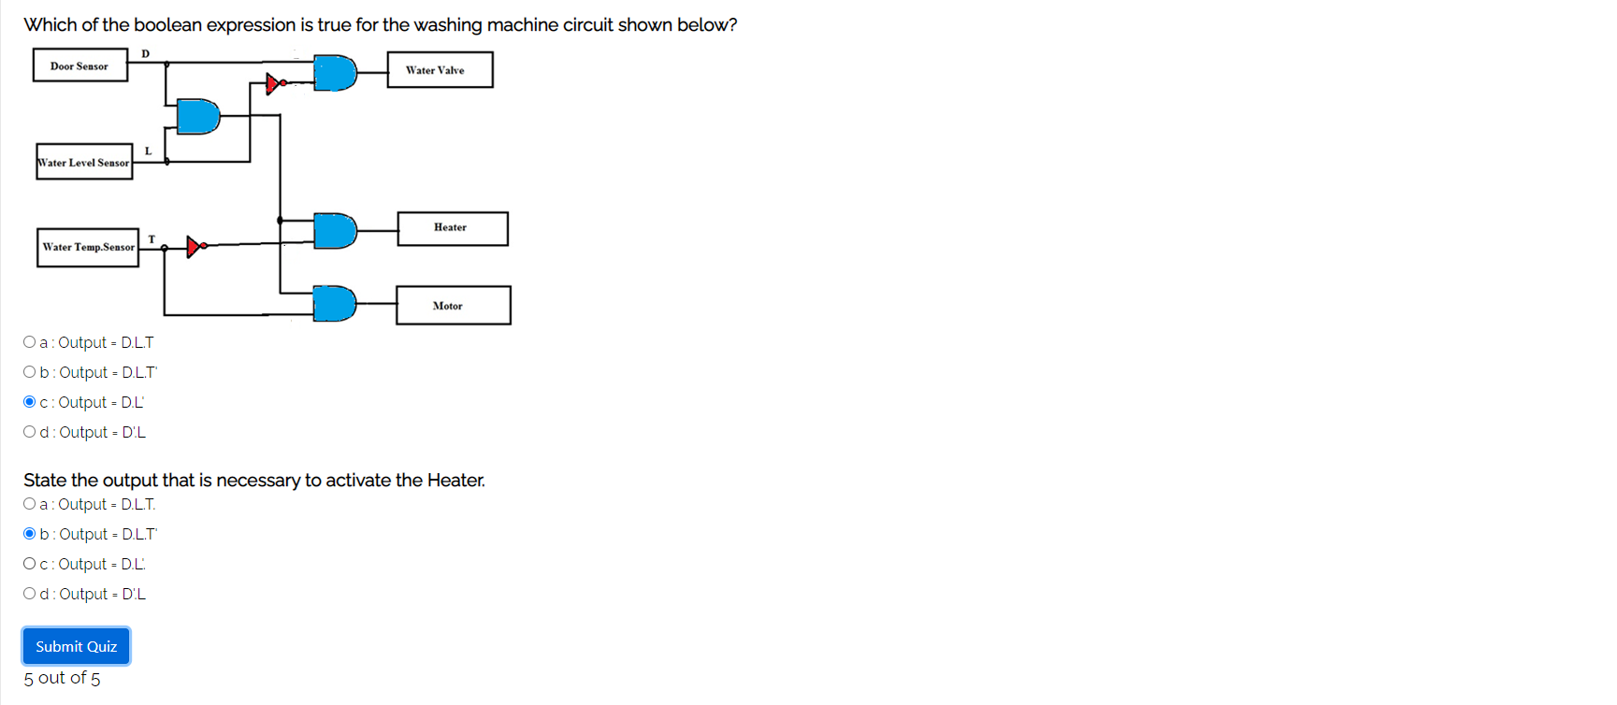

* **Simulation :-**

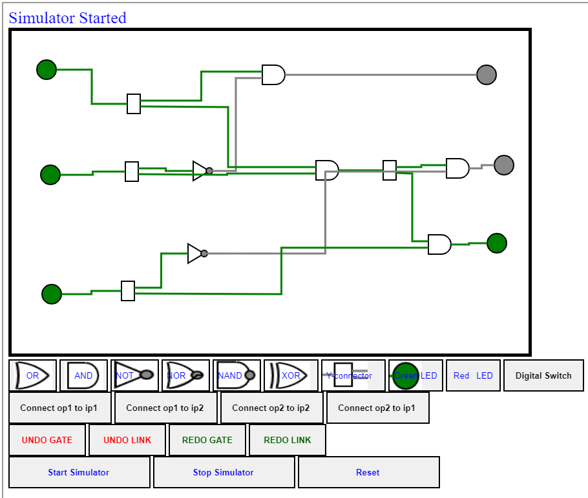

* 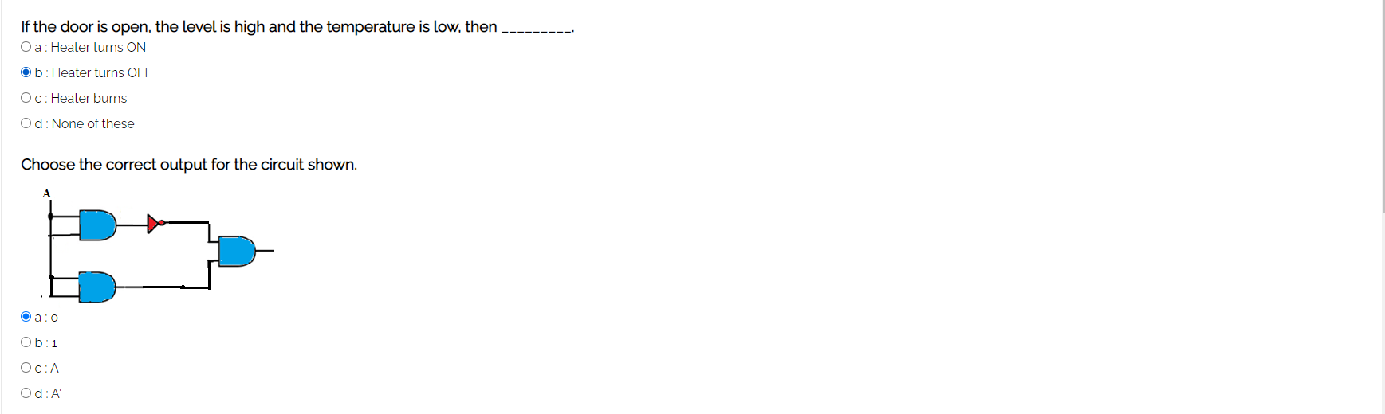**Post-test :-**

